[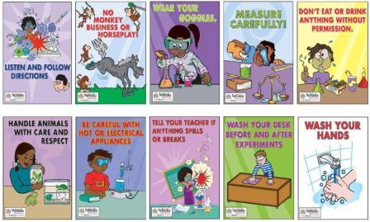](http://www.google.com/url?sa=i&rct=j&q=lab%20safety%20poster%20for%20kids&source=images&cd=&cad=rja&docid=Cj6JGs-yJ-9qeM&tbnid=Y9zXtnQtTCCNZM:&ved=0CAUQjRw&url=http://edtl3480f11.bgsu.wikispaces.net/Laura+Koch&ei=Of8lUvOaN6XZ2QXmp4C4Cw&bvm=bv.51495398,d.b2I&psig=AFQjCNFySZmYtga0qfAclqEmuOH314TzQA&ust=1378308280249886)